UNIT III
Arrays: Concepts, Using Array in C, Array Application, Two Dimensional Arrays, Multidimensional Arrays, Programming Example – Calculate Averages
Strings: String Concepts, C String, String Input / Output Functions, Arrays of Strings, String Manipulation Functions String/ Data Conversion, A Programming Example – Morse Code Enumerated, Structure, and Union: The Type Definition (Type def), Enumerated Types, Structure, Unions, and Programming Application.
Arrays
Concepts
- In C programming one of the frequently arising problem is to handle collection of similar type of data.
- For example, if the user wants to store marks of 100 students. This can be done crating 100 variables individually but this process is tedious and impractical. This type of problem handles in C programming using arrays.
- An array is defined as the collection of similar type of data items stored at contiguous memory locations
- Arrays can store the primitive type of data such as int, char, double, float, etc. It also has the capability to store the derived data types, such as pointers, structure, etc.
- The elements of array are accessed with reference to its position in array called index or subscript -> [ ] .
- The memory locations in the array are known as elements of array. The total number of elements in the array is called its length.
Using Array in C
- Array is of 2 types they are:
  - One-dimensional array – array having only one subscript variable is called one-dimensional array.
  - Multi-dimensional array (2D,3D..etc) - array having more than one subscript variable is called multi- dimensional arrays.

One-dimensional array
Declaring an array
datatype array_Name[arraySize];
Example: int X[100];
- Here, we declared an array, X, of integer type, and its size is 100. Meaning, it can hold 100 integer values.
- The size and type of an array cannot be changed once it is declared.
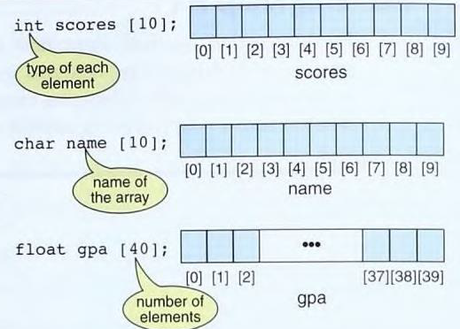
Accessing Array Elements
- Array elements can be accessed by indices. The index must be an integral value or an expression that evaluates to an integral value.
- If the array is declared as:
float mark[5];
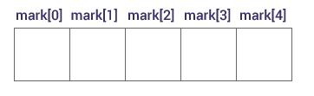
- Here, the first element is mark[0], the second element is mark[1] and so on.
- Arrays have 0 as the first index. In this example, mark[0] is the first element. If the size of an array is n, the index of last element is n-1.
- If the starting (base)( address of mark[0] is 2120. Then, the address of the mark[1] will be 2124. Similarly, the address of mark[2] will be 2128 and so on. This is because the size of a float is 4 bytes.
- The index is an expression, typically the value of a variable. To process all the elements in marks, a loop similar to the following code is used:
for(i=0;i<10; i++)
process (scores[i]);
- Process can be printf or scanf
Initializing an array
- After an array is declared it must be initialized otherwise it will contain garbage value so before using the array we must initialize the array or read some meaningful data into it.
- An array can be initialized either at compile time or runtime.
i) Compile time array initialization
Syntax: data type array[size]={value1,value2……valuen}
int mark[5] = {19, 10, 8, 17, 9};
Therefore, curly brackets {} are used to write the values and every value is separated by commas.
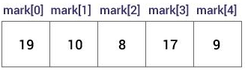
- C array indices start from 0. So for array with n elements, the index of the last element is n-1.
- Some different types of initializations are:
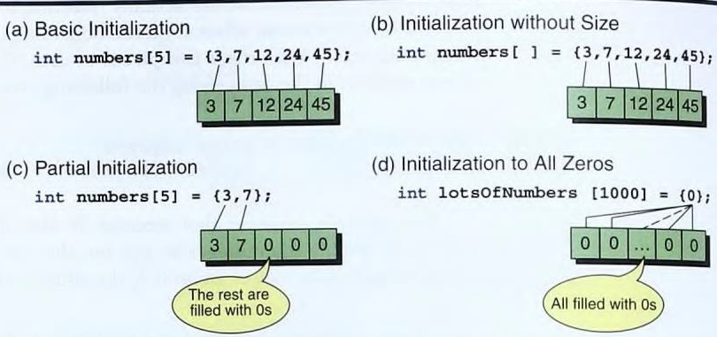
Inputting and outputting Values
- Another way to fill the array is to read the values from the keyboard or a file.
- This method of inputting values can be done using a loop. For example,
for (i = 0; i < 10; i++)
scanf ("%d", &mark [i]);
- First, we start the index i, at 0. Since the array has 9 elements, we must load the values from index locations 0 through 8.
- The elements of an array can be displayed on the screen by using printf statement and specify the elements.
Example:
#include<stdio.h>
main()
{
int i,j;
int arr[5];
for(i=0;i<5;i++)
{
printf(“enter arr[%d] element”);
scanf(“%d”,&arr[i]);
}
for(j=0;j<5;j++)
{
printf(“arr[%d] = %d\n”,j,arr[i]);
}
}
Assigning Values
- We can assign values to individual elements using the assignment operator.
- A simple assignment statement for scores is seen below.
mark [4] = 23;
- We cannot assign one array to another array, even if they match fully in type and size. We have to copy arrays at the individual element level.
- For example, to copy an array of 25 integers to a second array of 25 integers, we could use a loop, as shown below.
for (i = 0; i < 25; i++)
second[i] = first[i];

Accessing elements out of its bound
- Suppose you declared an array of 10 elements. Let's say,
int testArray[10];
- We can access the array elements from testArray[0] to testArray[9].
- If we try to access testArray[12]. The element is not available. This may cause unexpected output (undefined behavior).
Program to find the average of n numbers using arrays
#include <stdio.h>
int main()
{
int A[10], i, n, sum = 0, average;
printf("Enter number of elements: ");
scanf("%d", &n);
for(i=0; i<n; ++i)
{
scanf("%d", &marks[i]);
sum += marks[i];
}
average = sum/n;
printf("Average = %d", average);
return 0;
}
Advantages of C Array:
1) Code Optimization: Less code to the access the data.
2) Ease of traversing: By using the for loop, we can retrieve the elements of an array easily.
3) Ease of sorting: To sort the elements of the array, we need a few lines of code only.
4) Random Access: We can access any element randomly using the array.
Disadvantage of C Array:
1) Fixed Size: Whatever size, we define at the time of declaration of the array, we can't exceed the limit.
Array Application
- To store elements of same data type.
- To sort elements
- To perform matrix operations
- Arrays are used in CPU scheduling
- Used in Statistical applications like frequency distributions and histograms.
Two Dimensional Arrays (or) Matrices(or)Table
- An array having two subscripts where one subscript denotes row and other denotes column is known as two dimensional array.
Syntax: datatype array_name[rows][columns];
Example: int X[3][3];
- Here, 3 is the number of rows, and 3 is the number of columns.
- Elements in two-dimensional arrays are commonly referred by x[i][j] where i is the row number and ‘j’ is the column number.
- A two – dimensional array can be seen as a table with ‘x’ rows and ‘y’ columns where the row number ranges from 0 to (i-1) and column number ranges from 0 to (j-1). A two – dimensional array ‘x’ with 3 rows and 3 columns is shown below:
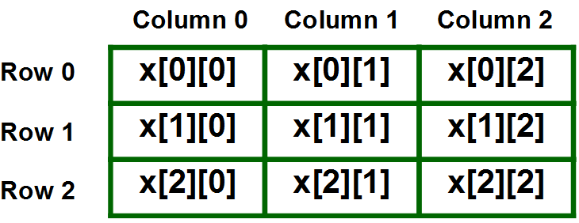
Initialization of 2D Array in C
- There are two ways in which a Two-Dimensional array can be initialized.
First Method:
int x[3][4] = {0, 1 ,2 ,3 ,4 , 5 , 6 , 7 , 8 , 9 , 10 , 11};
- The above array has 3 rows and 4 columns. The elements in the braces from left to right are stored in the table also from left to right.
- The elements will be filled in the array in the order, first 4 elements from the left in first row, next 4 elements in second row and so on.
Better Method:
int x[3][4] = {{0,1,2,3}, {4,5,6,7}, {8,9,10,11}};
- This type of initialization makes use of nested braces. Each set of inner braces represents one row.
- In the above example there are total three rows so there are three sets of inner braces.
Accessing Elements of Two-Dimensional Arrays
- Elements in Two-Dimensional arrays are accessed using the row indexes and column indexes.
Example: int value=x[2][1];
- The above example represents the element present in third row and second column.
Program using nested loop to handle 2-D Array
#include <stdio.h>
int main ()
{
int a[5][2] = { {0,0}, {1,2}, {2,4}, {3,6},{4,8}};
int i, j;
for ( i = 0; i< 5; i++ )
{
for ( j = 0; j < 2; j++ )
{
printf(" %d\n", a[i][j] );
}
}
return 0;
}
Multidimensional Arrays
- Multidimensional Arrays can have three, four or more dimensions.
- The first dimension is called a plane, which consists of rows and columns. In C, the three dimensional array is taken as an array of two dimensional arrays. It is an array of arrays of arrays.
- The following figure shows an array of three dimensions.
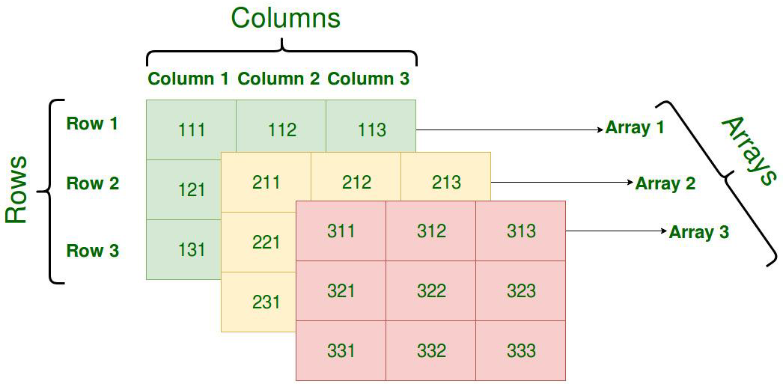
Declaring Multidimensional Arrays
- These arrays must be declared before being used. It can be declared as shown below.
For example: int A[3][4][5];
- One dimension for rows, One for columns and One for Planes.
int A[planes][rows][columns];
Initialization
- Declaration only reserves space for the elements in the array. No values will be stored in the array.
- To store the values, we must either initialize the elements or read from the keyboard or assign the values to each element.
intA[2][3][4] = {
// Plane 0
{ {1,2,3,4 }, {5,6,7,8}, {9,0,1,2} } ,
// Plane 1
{ {8,9,7,6}, {5,4,3,2}, {1,0,2,3} }
};
- All elements can be initialized to zero as intA[2][3][4] = {0};
Strings
String Concepts
- String is a series of characters treated as a unit. Strings can also be considered as a special type of array. It is a one-dimensional array.
- A string is terminated by null character (‘\0’). String is enclosed in double quotes (“ “).
- <string.h> header file contains string pre-defined functions.
Example: char c[]= “Hello”;
- The compiler encounters a sequence of characters enclosed in the double quotation marks; it appends a null character ‘\0’ at the end by default.
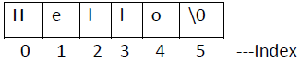
- A string can accommodate in two different ways
  - Fixed-length string
  - Variable length string
Fixed-length string
- It is a type of string where length of string is fixed. The space is fixed.
- There are some disadvantages related to fixed length strings, For example, if we have a large string and you have reserved smaller space than larger. Then the string will not be stored.
- If we have a small string and we have reserved larger space than limited memory is wasted. Once defined, length of string cannot be changed.
- To solve these problems, we have variable length strings.
Variable-length string
- These strings can contrast and expand according to requirement of string length.
- There must be some way to tell when we get to the end of the data. we have two general approaches and they are as follows:
  - Length controlled string
  - Delimited string
- Length-controlled strings add a count that specifies the number of characters in the string.
- There is a disadvantage that is if we have 4-byte length string, we need 5 bytes memory. Because that additional bit is used to store the length of the string.
- Another technique used to identify the end of the string is the delimiter at the ends of delimited strings.
- The major disadvantage of the delimiter is that it eliminates one character from being used for data.
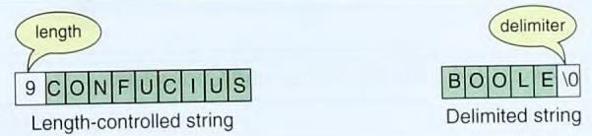
- The most common delimiter is the ASCII null character, which is the first character in the ASCII character sequence (\0).
C strings
- A C string is a variable-length array of characters that is delimited by the null character.
Storing Strings
- In C, a string is stored in an array of characters. It is terminated by the null character ('\0‘).
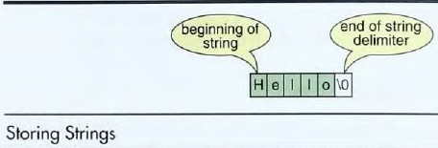
String Literals
- In C, a string is stored as an array of characters. It is terminated by a null character (\0).
- In a string we should know what the starting point is and ending point in the string. The name of the string is a pointer to the beginning of the string, null delimiter pointes the ending of the string.
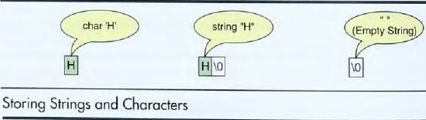
- The character requires only one memory location. The one-character string requires two memory locations: one for the data and one for the delimiter.
The String Delimiter
- We are using null character as delimiter at the end of the string. When memory allocating space character array, reserve space to hold null character also.
#include<stdio.h>
int main()
{
char a[]={‘a’, ’b’, ’c’, ’d’, ’\0’, ’d’, ’e’, ’f’, ’\0’ };
int i,len;
printf(“the string is : %s”, a);
len=strlen(a);
for(i=0; i<len; i++)
printf(“%c”, a[i]);
printf(“using percentage s: %s”,a);
return 0;
}
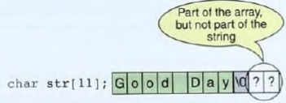
String Literals
- A string literal or is also known, string constant. It is a sequence of characters enclosed in double quotes.
- For example, each of the following is a string literal:
"C is a high-level language"
"Hello"
"abed"
Strings and characters
- When we need to store a single character, we have two options.
- We can store the data as a character literal or as a string literal. To store it as a character literal, we use single quote marks. To store it as a string literal, we use double quote marks.
- There is difference when we do manipulations on character and string. For example, to move a character from one location to another requires an assignment. Moving a string requires a function call.
- Another important difference between a string and a character is how we represent absent of data. We often specify a space (‘ ‘), or a null character (\0) represents the absence of data.
Referencing String literals
- A string literal is stored in memory. Just like any object stored in memory, it has an address. But, we can refer to a string literal by using pointers.
- 1 is a literal, since it is an array of characters, is itself a pointer constant to the first element of the string.
- Generally, when we use it, we are referring to the entire string. It is possible, to refer to only one of the characters in the string, as shown in Figure
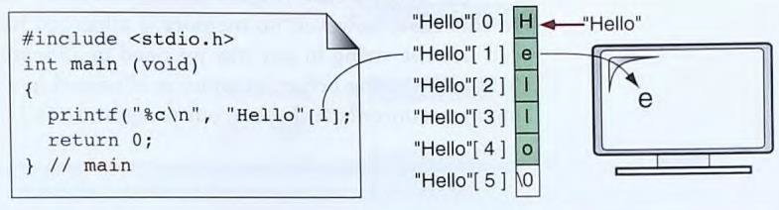
Declaring Strings
- C has no string type. As strings are a sequence of characters to declare a string we use character arrays for storing strings.
- A string declaration for an eight – character string, including its delimiter, is shown below.
char str [9];
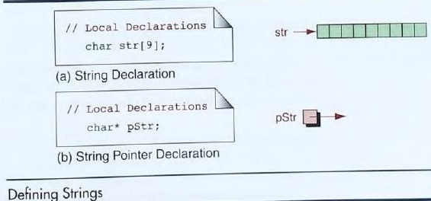
- Memory for strings must be allocated before the string can be used.
Initializing Strings
- We can initialize strings in a number of ways. The value is a string literal.
Example char str[9] = "Good Day";
- Do not need to indicate the size of the array if we initialize it when it is defined.
char month[] = "January";
- In this case, the compiler will create an array of 8 bytes and initialize it with January and a null character.
- C provides two more ways to initialize strings.
char* pStr = "Good Day";
char str[9] ={’G','o','o', ‘d', ' ', D ', ' a ', ' y ' , ' \ 0 ' };
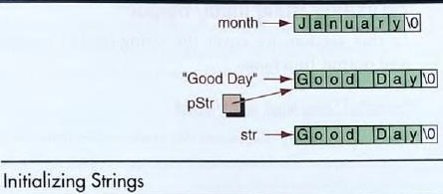
String Input/ Output Functions
- C provides two basic ways to read and write strings.
  - formatted input/output
    - scanf/ fscanf
    - printf/fprintf
  - unformatted input/output
    - getchar()/gets()
    - putchar()/puts()
Formatted String Input: scanf/ fscanf
- scanf() function can used with “%s” format specifier to read a string of characters.
- The problem with the scanf() function is that it stops reading when white space character is encountered that means at the time of giving input through keyboard we should not give whitespace between the characters.
char month[ 10];
scanf( " %s", month); // No need to use & before month
(or)
scanf( " %s", &month);
scanf( " %9s", month);
- The maximum number of characters at nine while the array size is ten. This is because scanf will read up to nine characters and then insert the null character.
- If the user accidentally enters more than nine characters, the extra characters will he left in the input stream.
Formatted String Output: printf/ fprintf
- They use the same string conversion codes that we used for string input.
Justification Flog
- The justification flag (-) is used to left justify the output.
- Width can specify, if the length of the string is less than the format width. The justification flag results in the output being left justified, as shown below. If no flag is used, the justification is right.
printf("|%-30s|\n", "This is the string ");
Output:
| This is the string
Minimum Width
- The width sets the minimum size of the string in the output.
- If it is used with flag, the string is printed right justified as shown below.
printf( "|%30s|\n", "This is the string");
Output:
| This is the string|
Precision
- Strings can get quite long. Because the width is minimum number of characters that can be printed, a long string can easily exceed the width specified, which destroys column formatting.
- Therefore, C uses the precision option to set the maximum number of characters that will be written.
printf( "|%-15.14s|","12345678901234567890");
Output: |12345678901234 |
- The maximum number of characters to be printed is specified by the precision in the format string of the field specification.
#include<stdio.h>
int main
{
char name[20];
printf(“enter name:”);
scanf(“%s”, name);
printf(“your name is %s”, name);
return 0;
}

Output:
Enter name: Dennis Ritchie
Your name: Dennis Ritchie
gets and fgets
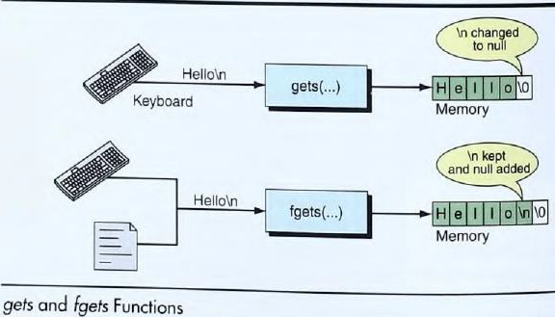
gets( )
- The C function char *gets(char *str) reads a line from stdin and stores it into the string pointed to by str.
- It stops when either the newline character is read or when the end-of-file is reached, whichever comes first.
Declaration
char *gets(char *str);
- str − This is the pointer to an array of chars where the C string is stored.
- This function returns str on success, and NULL on error, while no characters have been read.
#include <stdio.h>
#define MAX 15
int main()
{
char buf[MAX];
printf("Enter a string: ");
gets(buf);
printf("string is: %s\n", buf);
return 0;
}

Output:
Enter a string: Dennis
String is: Dennis
- When a character array of 15 characters and input is greater than 15 characters, gets() will read all these characters and store them into variable.
- gets() do not check the maximum limit of input characters, so at any time compiler may return buffer overflow error.
fgets( )
- The C function char *fgets(char *str, int n, FILE *stream) reads a line from the specified stream and stores it into the string pointed to by str.
- It stops when either (n-1) characters are read, the newline character is read, or the end-of-file is reached, whichever comes first.
Declaration
char *fgets(char *str, int n, FILE *stream)
- str − This is the pointer to an array of chars where the string read is stored.
- n − This is the maximum number of characters to be read (including the final null-character).
- stream − This is the pointer to a FILE object that identifies the stream where characters are read from.
- On success, the function returns the same str parameter.
- If the End-of-File is encountered and no characters have been read, the contents of str remain unchanged and a null pointer is returned. If an error occurs, a null pointer is returned.
#include <stdio.h>
#define MAX 15
int main()
{
char buf[MAX];
fgets(buf, MAX, stdin);
printf("string is: %s\n", buf);
return 0;
}
Output:
Hello and welcome Dennis Ritchie
String is: Hello and welc
- The maximum number of characters are 15 and input length is greater than 15 but still fgets() will read only 15 character and print it.
Arrays of Strings
- A string is an array of characters; so, an array of strings is an array of arrays of characters.
- The maximum size is the same for all the strings stored in a two-dimensional array.
Syntax char array_name[size][length];
- Size is the maximum number of strings.
- Length is the maximum number of characters in each string
#include <stdio.h>
void main()
{
char names[10][30];
int i,n;
printf("Enter total number of names: ");
scanf("%d",&n);
printf("\nEnter %d names...\n",n);
for(i=0; i<n;i++)
scanf("%s",names[i]);
printf("\nNames are...\n");
for(i=0; i<n; i++)
printf("%s ",names[i]);
}
Output:
Enter total number of names:4
Enter 4 names…
Prathap
Praveen
Pradeep
Praneeth
Names are…
Prathap
Praveen
Pradeep
Praneeth
String to Number
- The standard library (stdlib.h) library provides several functions that convert a string to a number. The most important are:
  - String to long
  - String to double
String to Long
- The C function long int strtol(const char *str, char **endptr, int base) converts the initial part of the string in str to a long int value according to the given base, which must be between 2 and 36 inclusive, or be the special value 0.
Declaration
long int strtol(const char *str, char **endptr, int base)
- str − This is the string containing the representation of an integral number.
- endptr − This is the reference to an object of type char*, whose value is set by the function to the next character in str after the numerical value.
- base − This is the base, which must be between 2 and 36 inclusive, or be the special value 0.
- This function returns the converted integral number as a long int value, else zero value is returned.
#include <stdio.h>
#include <stdlib.h>
int main ()
{
char str[30] = "2030300 This is test";
char *ptr;
long ret;
ret = strtol(str, &ptr, 10);
printf("The number(unsigned long integer) is %ld\n", ret);
printf("String part is |%s|", ptr);
return 0;
}
Output:
The number(unsigned long integer) is 2030300
String part is | This is test|
String to double
- The C function double strtod(const char *str, char **endptr) converts the string pointed to by the argument str to a floating-point number (type double).
- If endptr is not NULL, a pointer to the character after the last character used in the conversion is stored in the location referenced by endptr.

Declaration
double strtod(const char *str, char **endptr);
- str − This is the value to be converted to a string.
- endptr − This is the reference to an already allocated object of type char*, whose value is set by the function to the next character in str after the numerical value.
- This function returns the converted floating-point number as a double value, else zero value (0.0) is returned.
#include <stdio.h>
#include <stdlib.h>
main ()
{
char str[30] = "20.30300 This is test";
char *ptr;
double ret;
ret = strtod(str, &ptr);
printf("The number(double) is %lf\n", ret);
printf("String part is |%s|", ptr);
}
Output:
The number(double) is 20.303000
String part is | This is test|
String Manipulation functions
- The string handling functions are defined in string.h header file.
- Hence, we need to include string.h header file whenever we use these string handling functions in your program.
strlen()
- strlen() function returns the length of the string in bytes.
Syntax int strlen(char *str );
- The strlen() function calculates the length, in bytes, of str.
- It does not include the null terminating character. strlen() function returns integer value.
#include <stdio.h>
main()
{
char str1[20] = "Hello world";
int len;
len=strlen(str1);
printf("Length of string1 : %d\n", len)
}
Output:
Output: Length of string1: 11
strcpy()
- strcpy() function is used to copy the contents of one string into another string.
Syntax char *strcpy (char *str1, char *str2);
- The strcpy function copies characters from str2 to str1 and including the terminating null character.
- The str2 should be a variable and str1 can either be a string constant or a variable.
- The strcpy function returns a string str2.
#include <stdio.h>
int main()
{
char str1[20] , str2[20];
strcpy(str1, "Hello");
printf("str1 = %s\n", str1);
strcpy(str2,str1 );
printf("str2 = %s\n", str2);
}
Output:
Str1 = Hello
Str2 = Hello
strcat()
- strcat() is used to concatenate two strings.
Syntax char *strcat(ch ar *str1, const char *str2);
- The strcat() function concatenates or appends str2 to str1. All characters from str2 are copied including the terminating null character.
- The str1 should be a variable and str2 can either be a string constant or a variable.
- The strcat() function returns the string str1.
#include <stdio.h>
void main()
{
char str1[20];
char str2[20];
strcpy(str1, "Computer");
strcpy(str2, "Program");
strcat( str1, str2 );
printf("Concatenated String : %s\n", str1 );
}
Output :
Concatenated String : ComputerProgram
strcmp()
- The strcmp( ) function compares two strings and returns an integer.
- strcmp() function does a case sensitive comparison between two strings.
- The str1 and str2 can either be a string constant or a variable.
Syntax int strcmp(char *str1, char *str2);
- This function returns integer value after comparison.
  - Less than zero - str1 is less than str2
  - Zero - str1 is equal to str2
  - Greater than zero - str1 is greater than str2
#include <stdio.h>
void main()
{
char str1[20]; char str2[20];
strcpy(str1, "Hello");
strcpy(str2, "Hai");
printf("Return Value is : %d\n", strncmp( str1, str2));
printf("Return Value is : %d\n", strncmp(“tec” ,”tec” ));
printf("Return Value is : %d\n", strncmp(“ABC ,”BCD” ));
}
Output:
Return Value is : positive value
Return Value is : 0(zero)
Return Value is : negative value
strstr()
- The strstr() function locates the first occurrence of the string str2 in the string str1 and returns a pointer to the beginning of the first occurrence.
- If no such sub string exists in str1, a null pointer is returned.
Syntax char *strstr(char *str1, char *str2);
#include <stdio.h>
int main()
{
char s1 [] = "My House is small";
char s2 [] = "My Car is green";
printf ("Returned String 1: %s\n", strstr (s1, "House"));
printf ("Returned String 2: %s\n", strstr (s2, "Car"));
}
Output:
Returned String 1: House is small
Returned String 2: Car is green
#include <stdio.h>
#include <string.h>
main()
{
char s1[80], s2[80];
gets(s1);
gets(s2);
printf("lengths: %d %d\n", strlen(s1), strlen(s2));
if(!strcmp(s1, s2))
printf("The strings are equal\n");
strcat(s1, s2);
printf (''%s\n", s1);
strcpy(s1, "This is a test.\n");
puts(s1);
if(strchr("hello", 'e'))
printf("e is in hello\n");
if(strstr("hi there", "hi"))
printf("found hi");
}
Output:
lengths: 5 5
The strings are equal
hellohello
This is a test.
e is in hello
found hi
- The following are available in <string.h> header file.
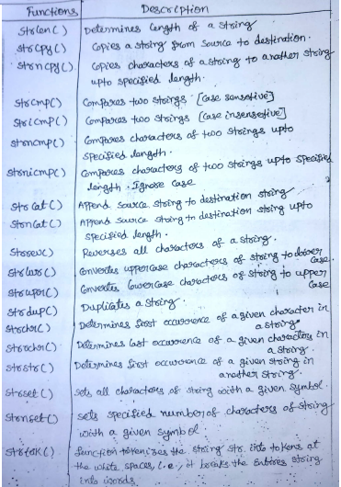
String/ Data Conversion
- The sscanf() function allows us to read formatted data from a string rather than standard input or keyboard.
Syntax int sscanf(const char *str, const char * control_string [ arg_1, arg_2, ... ]);
- The first argument is a pointer to the string from where we want to read the data.
- The rest of the arguments of sscanf() is same as that of scanf().
- It returns the number of items read from the string and -1 if an error is encountered.
#include<stdio.h>
#include<string.h>
int main()
{
char *str = "Tom Manager 28";
char name[10], designation[10];
int age, ret;
ret = sscanf(str, "%s %s %d", name, designation, &age);
printf("Name: %s\n", name);
printf("Designation: %s\n", designation);
printf("Age: %d\n", age);
return 0;
}
Expected Output:
Name: Tom
Designation: Manager
Age: 28
Data to String Conversion
- The sprintf() works just like printf() but instead of sending output to console it returns the formatted string.
Syntax: int sprintf(char *str, const char *control_string, [ arg_1, arg_2, ... ]);
- The first argument to sprintf() function is a pointer to the target string.
- The rest of the arguments are the same as for printf() function.
- The function writes the data in the string pointed to by str and returns the number of characters written to str, excluding the null character.
- The return value is generally discarded. If an error occurs during the operation, it returns -1.
// Example Program
#include<stdio.h>
#include<string.h>
int main()
{
char name[30], designation[30], info[60];
printf("Enter your name: ");
gets(name);
printf("Enter your designation: ");
gets(designation);
sprintf(info, "Name: %s \n Designation: %s \n ", name, designation);
printf("\n %s", info);
return 0;
}
Expected Output:
Enter your name: Bob
Enter your designation: Developer
Name: Bob
Designation: Developer
Enumerated, Structure, and Union
User-defined data types
- User-defined data types allow users to defined new data type, which would represent to the existing data type.
- They are 2 types of user-defined data types
  - type def
  - enum (enumeration)
The Type Definition (Type def)
- The typedef statement is used with the existing data type to give new data type.
Syntax: typedef existing data type userdefined data type;
typedef int a;
a v;
- V have the properties of integer
v=100;
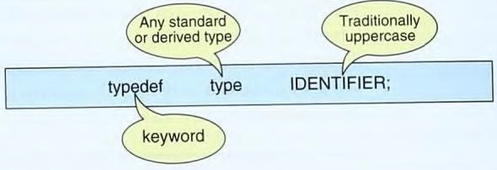
#include<stdio.h>
main()
{
typedef unsigned int cse;
cse v;
v=84;
printf(“usha roll no is %u:”,v);
}
enum (enumeration)
- Enumeration is a user-defined data type. It consists of integral constants, by using enum keyword enumeration is defined.
Syntax: enum identifier (or) user-defined {value1,value2,………valuen};
- value1,value2,………valuen creates set of enum values.
- identifier we are creating own variables.
Example:
enum month { jan,feb,mar,…………dec};
enum month nmonth;
- Assigned to first enum value is 0.
- Numerically jan is 0,feb is 1,mar is 2…… dec is eleven are the given values.
#include<stdio.h>
main()
{
enum week{mon,tue,wed,thru,fri,sat,sun};
enum week nweek;
nweek=sat;
printf(“the value of sat is %d:”,nweek);
}
Structure
- Structure is the collection of variables of different types grouped together under a single name.
- Structure is referred to as a derived data type.
- Structure allows to store multiple variables of any type in one place.
- Each variable within a structure is called a member or field of the structure.
Structure Type Declaration
- C has two ways to declare a structure:
- tagged structures
- type-defined structures.
Tagged Structure
- A tagged structure starts with the keyword struct.
- The second element in the declaration is the tag.
- The structure declaration is terminated by a semicolon because a structure declaration is a statement.
Example: consider the student database in which each student has a id, name and grade points.
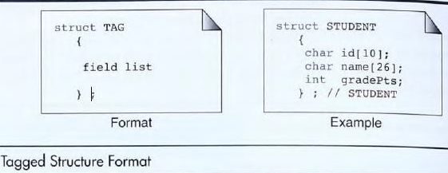

Type Declaration with typedef
- Another way to declare a structure is to use a type definition, typedef.
- The type-defined structure differs from the tagged declaration in two ways. First, the keyword, typedef, is added to the beginning of the definition.
- Second, an identifier is required at the end of the block; the identifier is the type definition name.
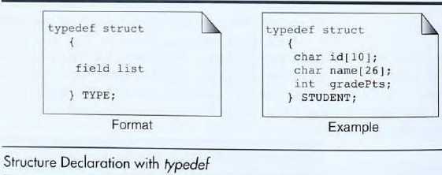
Structure variables declaration
- It is possible to declare variables of a structure, after a structure is defined.
- Structure variables can be declared in following two ways.
- Stud is the variable of the structure.
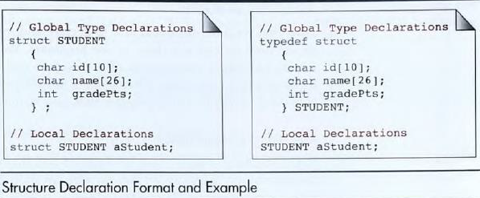
C program to find the amount of memory allocated for a given structure.
struct student // structure name
{
int roll_no; // 4 bytes
char name[20]; // 20 bytes
char course[20]; // 20 bytes
int m1,m2,m3; // 12 bytes
float average; // 4 bytes
} stud;
void main()
{
printf(“ size = %d \n”,sizeof(struct student)); //or
printf(“ size = %d \n”,sizeof(stud));
}
Output:
size = 60 ---------(4+20+20+12+4=60)
Size = 60
Initialization
- We can initialize a structure by following rules that are similar to the rules for array initialization.
- The initializers are enclosed in braces and separated by commas. They must match their corresponding types in the structure definition.
- Structure can be initialize at the time
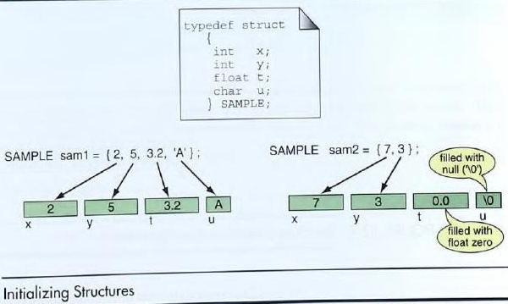
- The first example shows an initializer for each field. Note how they are mapped to the structure in sequence.
- The second example demonstrates what happens when not all fields are initialized.
- Like arrays, when one or more initializers are missing, the structure elements will be assigned null values, zero for integers and floating-point numbers, and null ('\0') for characters and strings.
Accessing Structure Members
- Structure members are accessed using the structure member operator (.), also called the dot operator, between the structure name and the member name.
Syntax Structurevariable . member-name;
- If we use the structure student in “Type Declaration with typedef," we would refer to the individual components as shown below.
aStudent.id, aStudent.name, aStudent.gradePoints
C program to access the structure elements and print on to the screen
typedef struct
{
int Rno;
char name[20];
char course[20];
}student;
void main()
{
struct student stud;
stud.Rno=1001;
strcpy(stud.name,”rithika”);
strcpy(stud.course,”B-Tech”);
printf(“Roll_no = %d \n”,stud.Rno);
printf(“Name = %s \n”,stud.name);
printf(“Course = %s \n”,stud.course);
}
Output :
Roll_no=1001
Name = rithika
Course = B-Tech
Pointer to structures
- Structures, like other types, can also be accessed through pointers. one of the most common methods used to reference structures
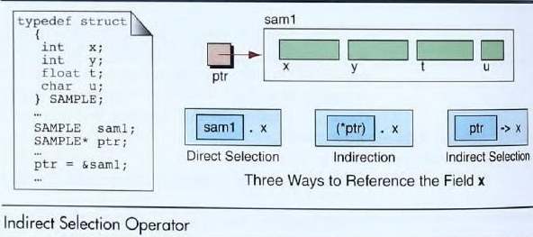

- To access the members of a structure using a pointer to that structure, we must use the arrow (->) operator.
typedef struct
{
int rno;
char name [20];
char course [20];
} student;
void main ()
{
student *stud;
stud->rno=1001;
strcpy(stud->name,"rithika");
strcpy(stud->course,"B-Tech");
printf("Roll_no = %d \n",stud->rno);
printf("Name = %s \n",stud->name);
printf("Course = %s \n",stud->course);
}
Output:
Roll_no=1001
Name = rithika
Course = B-Tech
Nested Structures
- When a structure includes another structure, it is a nested structure. There is no limit to the number of structures that can be nested,
- The date is in turn a structure that stores the month, day, and year. The time is also a structure that stores the hour, minute, and second.
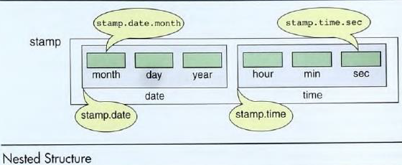

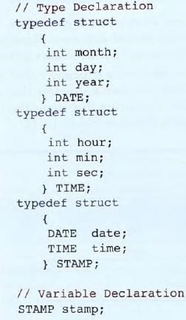
Referencing Nested Structures
- To access a nested structure, we include each level from the highest (stamp) to the component being referenced.
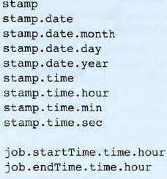
Nested Structure Initialization
- Each structure must he initialized completely before proceeding to the next member.
- Each structure is enclosed in a set of braces. For example, to initialize stamp, first we initialize date, then time, separated by a comma. To initialize date, we provide values for month, day, and year, each separated by commas.
STAMP stamp = {{05, 10, 1936}, {23, 45, 00}};
Array of Structures
- Structure is collection of different data type.
- An object of structure represents a single record in memory, if we want more than one record of structure type, we have to create an array of structure or object.
- As we know, an array is a collection of similar type, therefore an array can be of structure type.
Syntax struct structure_name
{
datatype variable1;
datatype variable2;
dataype variable 3;
……....
};
struct structure_name variable[index];

Usage of an array of structures
struct book
{
char name[20] ;
char author[20] ;
float price ;
};
struct book b[10] ; // array of structures
void main()
{
int i;
for (i = 0 ; i < 10 ; i++ )
{
printf ( "\nEnter name, price and pages " ) ;
scanf ( "%s %s %f", &b[i].name, &b[i].author, &b[i].price) ;
}
for( i = 0 ; i <= 10 ; i++ )
printf ( "\n%s %s %f", b[i].name, b[i].author, b[i].price) ;
}
Passing Entire Structure to Functions
- When a structure is used as an argument to a function, the entire structure is passed using the normal Call-by-value method.
struct book
{
char name [25];
char author [25];
int price;
} ;
void display (struct book b1)
{
printf ("\n %s -- %s -- %d", b1.name, b1.author, b1.price ) ;
}
void main()
{
struct book b1 = {“Let_us_C ", "yaswanth -- ", 250 } ;
display(b1); //passing structure members
getch();
}
Output:
Let_us_C – yaswanth -- 250

Unions
- Unions are conceptually similar to structure. The syntax of the union is also similar to that of structure.
- The only difference is in terms of storage. On structure each member has its own storage location, where as all members of union use a single shared memory location which is equal to the size of its largest data member.
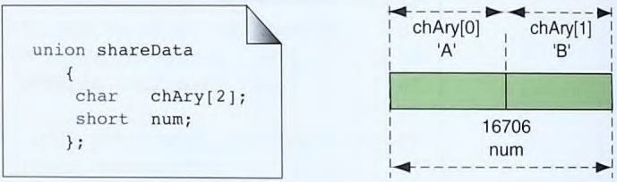
Referencing Unions
- To reference individual fields within the union, we use the direct selection (dot) operator.
- When a union is being referenced through a pointer, the selection operator (arrow) can be used.
shareData.num
shareData.chAry[0 ]
Accessing structure members with pointer
#include<stdio.h>
struct book
{
char name[10];
int price;
}
main()
{
struct book b;
struct book *ptr=&b;
ptr->name=”ravi”; //Accessing structure members
ptr->price=500;
}
Initializes
- C permits a union to be initialized, only the first type declared in union can be initialized when the variable is defined.
- The other types can only be initialized by assigning values or reading values into the union. When initializing a union, we must enclose the values in a set of braces, even if there is only one value.
# include <stdio.h>
typedef union
{
short num; char chAry[2];
} SH_CH2 ;
int main (void )
{
SH_CH2 data;
data.num = 16706;
printf( "Short: %hd\n", , data.num);
printf("Ch[0 ]: %c\n" , data.chAry[0]);
printf("Ch(l]: %c\n " , data.chAry[ 1 ]);
return 0;
}
Output:
Short: 16706
Ch[0]: A
Ch[1]: B
Unions and Structures
- In a union, each piece of data starts at the same memory location and occupies at least a part of the same memory.
- When a union is shared by two or more different data types, only one piece of data can he in memory at one time. Because two different types of data can be stored in the same union.
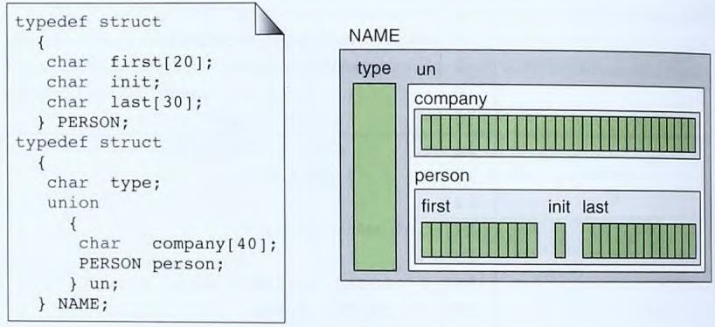
- When a union is defined, C reserves enough room to store the largest data object in the construct.
- In the above Figure, the size of the company name is 40 bytes and the size of the person name is 51 bytes.
- The size of the union structure is therefore 52 bytes (the size of the person name plus the type) are being stored.
- When a company name is to store the largest room regardless of what type of data stored, the last 11 bytes are present unused.

